1.1 Given an array of strings words, return the first palindromic string in the array. If there is no such string, return an empty string "". A string is palindromic if it reads the same forward and backward.
AIM:
ALGORITHM:
Start
• Iterate through each string s in the array words:
- Check if s is a palindrome:
  - Compare characters from the beginning and end moving inward.
  - If all characters match, then s is a palindrome.
- If s is palindrome:
  - Return s.
• If no palindrome is found after checking all strings:
- Return "".
End
PROGRAM:
def is_palindrome(s: str) -> bool:
return s == s[::-1]

def first_palindrome(words):
for w in words:
if is_palindrome(w):
return w
return ""

words = ["abc", "car", "ada", "racecar", "cool"]
print(first_palindrome(words))

INPUT AND OUTPUT:
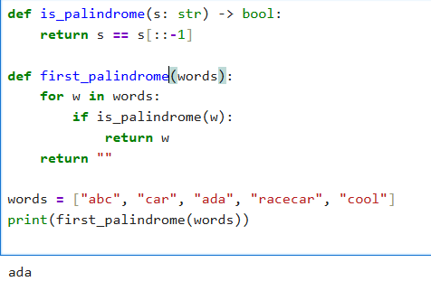

RESULT:
Thus the program to find first palindrome string in a array is successfully executed and output is verified.
1.2 You are given two integer arrays nums1 and nums2 of sizes n and m, respectively. Calculate the following values: answer1 : the number of indices i such that nums1[i] exists in nums2. answer2 : the number of indices i such that nums2[i] exists in nums1 Return [answer1,answer2].
AIM:
ALGORITHM:
Start
• Convert nums2 into a set (for O(1) lookup).
• Initialize answer1 = 0.
- For each element in nums1:
  - If element exists in set(nums2), increment answer1.
• Convert nums1 into a set (for O(1) lookup).
• Initialize answer2 = 0.
- For each element in nums2:
  - If element exists in set(nums1), increment answer2.
Return [answer1, answer2].
End
PROGRAM:
def count_matches(nums1, nums2):
set1, set2 = set(nums1), set(nums2)

answer1 = sum(1 for x in nums1 if x in set2)
answer2 = sum(1 for x in nums2 if x in set1)

return [answer1, answer2]

# Example
nums1 = [2, 3, 2]
nums2 = [1, 2]
print(count_matches(nums1, nums2))
INPUT AND OUTPUT:
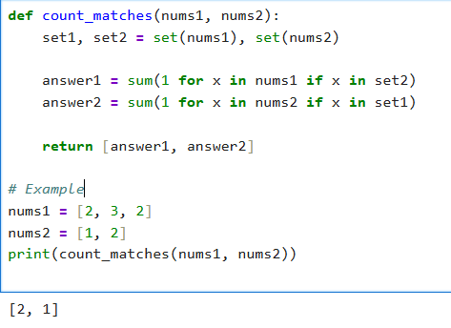
RESULT:
Thus the program to Find Indices with Elements Present in Both Arrays excuted successfully and output is verified.
1.3 .You are given a 0-indexed integer array nums. The distinct count of a subarray of nums is defined as: Let nums[i..j] be a subarray of nums consisting of all the indices from i to j such that 0 <= i <= j < nums.length. Then the number of distinct values in nums[i..j] is called the distinct count of nums[i..j]. Return the sum of the squares of distinct counts of all subarrays of nums. A subarray is a contiguous non-empty sequence of elements within an array.
AIM:
Sum of Squares of Distinct Counts of All Subarrays
ALGORITHM:
• Initialize answer = 0.
• For each starting index i (0 → n-1):
- Create a frequency map (hashmap).
- For each ending index j (i → n-1):
  - Insert nums[j] into the map (track counts).
  - The number of distinct elements = size of map.
  - Add (distinct_count)^2 to answer.
• Return answer.

PROGRAM:
def sum_of_squares_distinct(nums):
n = len(nums)
total = 0

for i in range(n):
seen = set()
for j in range(i, n):
seen.add(nums[j])
distinct_count = len(seen)
total += distinct_count ** 2

return total

# Example
nums = [1, 2, 1]
print(sum_of_squares_distinct(nums))

INPUT AND OUTPUT:
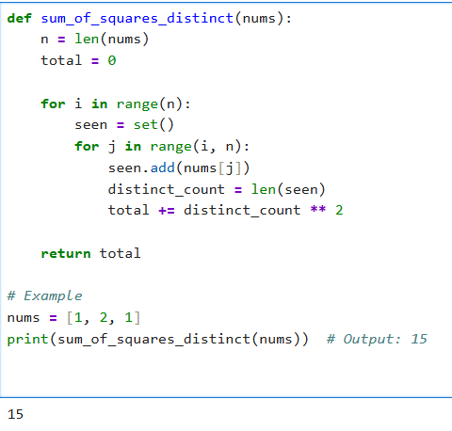
RESULT:
Thus the program for Sum of Squares of Distinct Counts of All Subarrays executed successfully and output is verified.
1.4 Given a 0-indexed integer array nums of length n and an integer k, return the number of pairs (i, j) where 0 <= i < j < n, such that nums[i] == nums[j] and (i * j) is divisible by k.
AIM:
Count Equal Pairs with Index Product Divisible by k
ALGORITHM:
- Initialize count = 0.
- Loop through all pairs (i, j) with i < j.
- If nums[i] == nums[j] and (i * j) % k == 0, increment count.
- Return count.

PROGRAM:
def count_pairs(nums, k):
n = len(nums)
count = 0

for i in range(n):
for j in range(i + 1, n):
if nums[i] == nums[j] and (i * j) % k == 0:
count += 1

return count
nums = [3,1,2,2,2,1,3]
k = 2
print(count_pairs(nums, k))
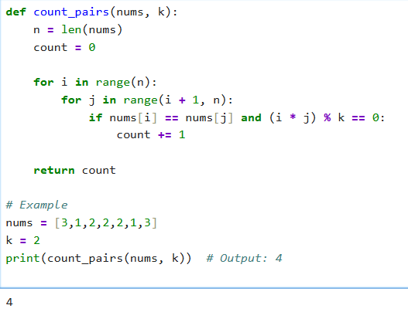
INPUT AND OUTPUT:

RESULT:
Thus the program to find Count Equal Pairs with Index Product Divisible by k
Executed successfully and output is verified.
1.5 Write a program FOR THE BELOW TEST CASES with least time complexity.
AIM:
Program to find Least time complexity
ALGORITHM:
• Initialize maxVal = nums[0].
• Traverse the array once.
- If nums[i] > maxVal, update maxVal = nums[i].
• After loop ends, return maxVal.

PROGRAM:
def find_max(arr):
return max(arr)

# Test cases
print(find_max([1, 2, 3, 4, 5])) # 5
print(find_max([7, 7, 7, 7, 7])) # 7
print(find_max([-10, 2, 3, -4, 5]))

INPUT AND OUTPUT:
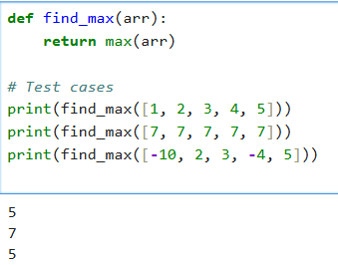

RESULT:
Thus the program to find least time complexity executed successfully and output is verified.

1.6 You have an algorithm that process a list of numbers. It firsts sorts the list using an efficient sorting algorithm and then finds the maximum element in sorted list.
AIM:
Find Maximum Element in a List
ALGORITHM:
• Input: A list of integers nums.
• Initialize maxVal = nums[0].
• Traverse each number x in nums:
- If x > maxVal, update maxVal = x.
• After traversal, return maxVal.
Output: The maximum element of the list.
PROGRAM:
def process_list(nums):
if not nums: # Empty list

return None
nums.sort() # Efficient sort (Timsort in Python, O(n log n))
return nums[-1] # Last element is maximum

# Test Cases
print(process_list([]))
print(process_list([5]))
print(process_list([3,3,3,3,3]))
print(process_list([1,4,2,7,3]))

INPUT AND OUTPUT:
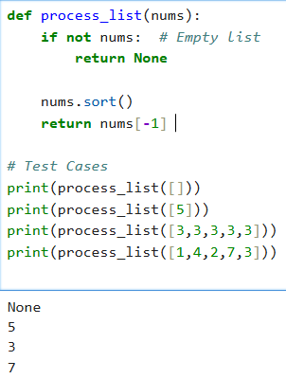
RESULT:
Thus the program to Find Maximum Element in a List ran succesully and op is verified.
1.7 Write a program that takes an input list of n numbers and creates a new list containing only the unique elements from the original list. What is the space complexity of the algorithm?
AIM: Extract Unique Elements from a List
ALGORITHM:
• Input: A list of n numbers.
• Create an empty set seen.
• Traverse each element x in the list:
- If x is not in seen, add it to seen.
• Convert seen into a list unique_list.
• Output: Return unique_list.

PROGRAM:
def unique_elements(nums):
return list(set(nums)) # removes duplicates, order not preserved

# Test Case
print(unique_elements([3, 7, 3, 5, 2, 5, 9, 2]))
INPUT AND OUTPUT:
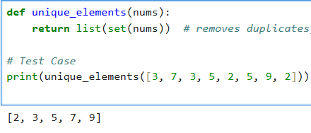
RESULT:
thus code for Extract Unique Elements from a List executed successfully and op is verified
1.8 Sort an array of integers using the bubble sort technique. Analyze its time complexity using Big-O notation. Write the code
AIM:
Bubble Sort Implementation and Time Complexity Analysis
ALGORITHM:
• Input: An array of integers arr of size n.
• Repeat the following n-1 times:
- Traverse the array from index 0 to n-i-2.
- Compare adjacent elements arr[j] and arr[j+1].
- If arr[j] > arr[j+1], swap them.
• After each iteration, the largest element among the unsorted part "bubbles up" to its correct position.
• Output: Sorted array.

PROGRAM:
def bubble_sort(arr):
n = len(arr)
for i in range(n-1):
swapped = False
for j in range(n-i-1):
if arr[j] > arr[j+1]:
arr[j], arr[j+1] = arr[j+1], arr[j]
swapped = True
# If no two elements were swapped in the inner loop, break
if not swapped:
break
return arr

# Test
nums = [5, 1, 4, 2, 8]
print("Sorted Array:", bubble_sort(nums))
INPUT AND OUTPUT:
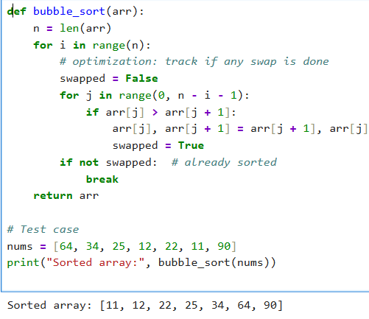
RESULT:
Thus the program Bubble Sort Implementation and Time Complexity Analysis executed successfully and op is verified
1.9 Checks if a given number x exists in a sorted array arr using binary search. Analyze its time complexity using Big-O notation.

AIM:
Binary Search in a Sorted Array
ALGORITHM:
Input: A sorted array arr and a target element key.
- Initialize two pointers:
  - low = 0
  - high = len(arr) - 1
- While low <= high:
  - Compute mid = (low + high) // 2.
  - If arr[mid] == key, return mid (position).
  - If arr[mid] < key, search right half (low = mid + 1).
  - Else search left half (high = mid - 1).
- If not found, return -1.
PROGRAM:
def binary_search(arr, key):
arr.sort() # ensure sorted
low, high = 0, len(arr) - 1

while low <= high:
mid = (low + high) // 2
if arr[mid] == key:
return mid + 1 # position (1-based index)
elif arr[mid] < key:
low = mid + 1
else:
high = mid - 1
return -1
X = [3, 4, 6, -9, 10, 8, 9, 30]
KEY = 10
pos = binary_search(X, KEY)

if pos != -1:
print(f"Element {KEY} is found at position {pos}")
else:
print(f"Element {KEY} not found")

INPUT AND OUTPUT:

RESULT:

